**Day 10 Assignment**

**Set up and installation of Ansible on Ec2 instance:**

**List of commands in master node**

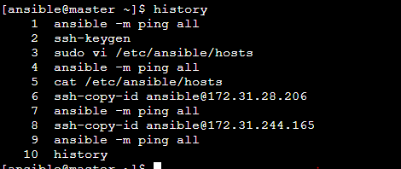

**List of commands in worker node 1:**

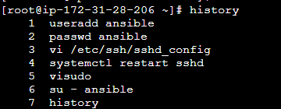

**List of commands in worker node 2:**

